13.05.2024

Hands on AWS config.

Pre-req

Make sure you have more than TWO buckets and one should be Versioning enabled and other can be disabled so that you can identity the complaince report.

https://aws.amazon.com/config/pricing/

Set up AWS Config >>>> Get started (NOT One Click)

Recording method >>> All resource types with customizable overrides

Leave all the options as it is till "Delivery method"

Choose a bucket from your account >>>> Choose your bucket

Choose the create bucket not choose bucket from your account

Choose Next

Rules >>> AWS Managed Rules (143) >>>> Please explore these rule

Search for "s3-bucket-versioning-enabled" and select

Next

Review & Confirm

Error showing

Now you can go inside and see whichever are complaint and non-complaint

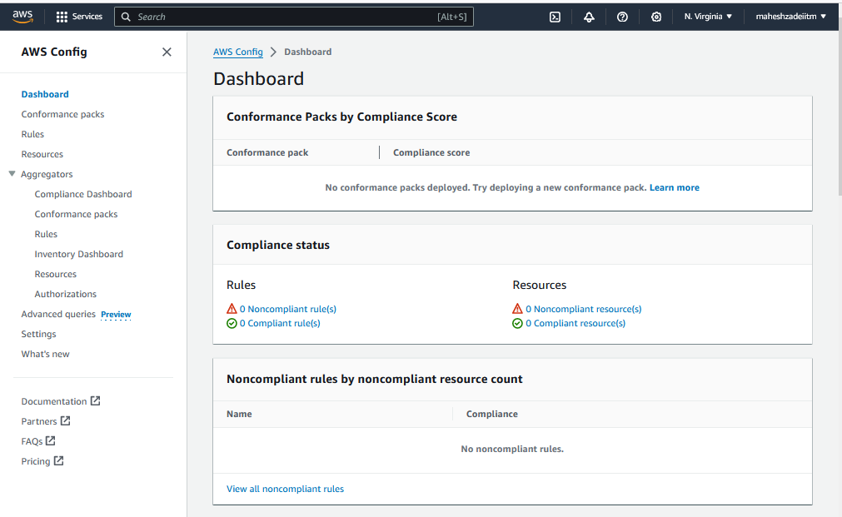

Check new Bucket is created todays dated 13th may 2024

1 rule is created

AWS Config Service done successfully

Thanks

Pls check and confirm .